**Boston University**

**Electrical & Computer Engineering**

**EC463 Senior Design Project**

First Semester Report

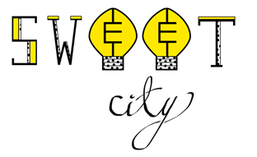

Submitted to

National Grid Sustainability Hub

912 Main St. Worcester, MA 01610

(774) 239-7587

[worcestersustainabilityhub@nationalgrid.com](mailto:worcestersustainabilityhub@nationalgrid.com)

by

Team 20

Team Members:

Jessica Cadreau jcadreau@bu.edu

Jennifer Fong jkfong@bu.edu

Cameron Graves cagraves@bu.edu

Makenna Hart hartm04@bu.edu

Steven Li listeven@bu.edu

Submitted: Monday December 12, 2016

#### Table of Contents

Table of Contents

Executive Summary

Introduction

Concept Development

System Description

First Semester Progress

Technical Plan

Budget Estimate

Attachments

Appendix 1 – Engineering Requirements

Appendix 2 – Gantt Chart

***(right click on Table of Contents to update fields and page numbers automatically)***

# Executive Summary

SWEET Grid

Team 20 – SWEET

Currently, many individuals are unaware of the importance of clean energy technologies. As of right now, our primary energy source is fossil fuel. However, due to greenhouse gas emissions, a decreasing amount of resources, and a declining cost efficiency, fossil fuels are negatively impacting the planet. Our goal is to increase awareness on this issue through interactive demonstrations.

The final deliverable will consist of solar, wind, energy efficiency, and smart grid modules. These four modules are encompassed in an interactive educational exhibit modeled around the city of Boston. The overall exhibit will serve to educate individuals on energy technologies as well as National Grid’s Smart Grid pilot program. This is accomplished through displaying power generation and consumption values on LCD screens.

Each module approaches clean energy or energy efficiency differently. The solar and wind modules generate power and drive visual loads. The power generated will also be displayed on an LCD screen so users are able to easily understand the concepts of power generation. The energy efficiency module will compare power consumption for LEDs and incandescent light bulbs. The power consumed will also help the user determine the efficiency of both. Power saved by using LEDs, shown on an LCD screen, will be used to drive a separate visual load. The Smart Grid module will depict National Grid’s Smart Grid pilot program. This will simulate a blackout and show the quick response. The response time will then be displayed on an LCD screen. A second screen will display details of the entire city’s energy generation and consumption. A Raspberry Pi 3 will be used to measure all data. Once the data is acquired, it will be sent to the module displays.

# Introduction

National Grid wants a safe, fun, and interactive Boston themed energy exhibit. It will educate customers on clean energy, energy efficiency, and their Smart Grid pilot program. The SWEET City exhibit includes four modules that generate power from solar and wind technologies, show power consumption with varying efficiencies, and explain the concept of the Smart Grid.

In 2015, solar and wind power only accounted for 6% of the United States’ electricity generation. Renewable generation and efficient uses of energy can help reduce the dangerously high levels of greenhouse gasses in the atmosphere. National Grid’s pilot Smart Grid program is improving energy efficiency attempts and blackout response.

Currently, utility companies send workers to gather the data needed to provide electricity. This, however, takes time and resources that could be better spent elsewhere. Instead, Smart Grid is a two way communication between customer and utility. This communication allows for a utility to more easily locate a blackout point rather than wait for a phone call that notifies them of a blackout. With this information, the utility can reroute power, bringing 80% of customers back online much quicker than before.

By designing four mobile energy modules, we can educate National Grid customers on current energy problems and future energy solutions in an interactive manner. Each module requires a screen displaying real-time power generation or usage statistics that vary with user interaction.

Our focus has been the solar module. By using series wired solar panels and a light source, we were able to design a circuit that powers an LED visual load attached to a small scale model of the natural gas tower in Dorchester. We were able to limit voltage and current to low, safe levels while also measuring these values with an MSP430.

Near-completion of the solar module provides proof of concept for the rest of the project. The same general approach to circuit design, safety, and data acquisition will be used in the other three modules. With completion of the solar module, we will split to approach the other three modules separately. This will allow for more progress towards the overall goals of the project.

The working solar module allows users to actively vary solar generation by simulating different weather patterns using provided lighting films. It also maintains safety standards and actively displays voltage supplied by the solar panels. All of these meet project requirements and will be useful in creating future modules.

By working on the first module together, we were all able to get a better understanding of project expectations. Using the solar module as a stepping stone, we can make an easy transition to the other modules while maintaining the same high levels of expectation.

Each module will have a fun and interactive component. In the solar module, a National Grid customer can turn a wheel of lighting films attached to the light source. The films, that simulate different weather patterns, allow the customer to see their direct effect on power generation. The wind module will vary power generation based on wind turbine blade type. Customers can switch out blades to see the effects of blade style on power generation. There will also be a separate wind turbine that is manually powered by the customer, giving them the chance to see their own power output. In the energy efficiency module, the user will be able to toggle a switch between LEDs and incandescent light bulbs. Both bulbs are given the same amount of power. Because LEDs consume less power, the excess power will be used to drive a separate load. In the Smart Grid module, the user will be able to cause a blackout by disconnecting a transmission line.

The project also includes a road that runs through the city, connecting each module. There will be electric vehicle charging stations placed on the roadside. Although these charging stations will not be functioning, they are there to create a more realistic view of what National Grid offers to its customers.

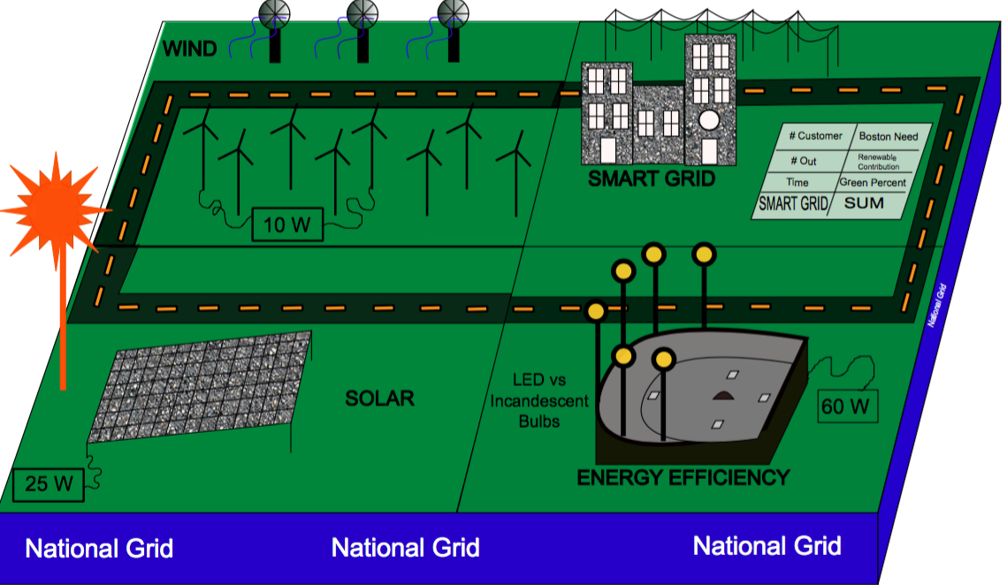

Figure 1. This is a basic representation of what the project will look like upon completion

# Concept Development

Clean energy technologies are crucial to a sustainable future. Currently, fossil fuels are our primary source of energy. Despite their low cost, they have significant contributions to global warming and are in finite supply. To amplify this problem, many people are not aware of the importance of these issues.

Expanding awareness and educating the public on this issue is the driving motivation behind this project. Our project is designed to easily educate and increase public awareness. Through our interactive modules, we will ensure that people have access to energy solution information. The public will learn efficiency options and alternative energy sources. In doing so, they can potentially reduce personal energy costs while also helping the environment. The exhibit will be designed to be understood and interactive for children of ages eight and up.

National Grid wants their customers to have a new and interactive way to understand clean energy technologies. By designing mobile energy modules, we will be able to educate the public about current energy problems and future energy solutions.

The SWEET City final product will consist of solar, wind, energy efficiency, and Smart Grid modules for ages eight and up. These four modules will be fun, safe, interactive, and able to function separately as well as together. The grouping of the modules will be able to be split into two separate parts. This will allow for separate demonstration locations.

Each module requires a screen that displays its real-time generation or usage statistics. These statistics will vary with user interaction. Users can change wind turbine blades, simulate different types of weather, or choose new lighting efficiencies. A main screen will display an overall summary of the combined grid and how the renewable energies are contributing to the city’s demand.

The entire SWEET City will be connected by a central road that has National Grid branded landmarks, as well as non-functioning electric vehicle charging stations. The road will lead toy cars to energy destinations throughout the city.

To keep the exhibit safe, we are using parts with low voltage outputs. The solar module uses two solar panels rated to 5V and the wind module will use a DC generator rated to 10V. With safety in mind, all circuits designed for this project have kept voltage under 15V and current less than 30 mA. This will avoid any potential risk to National Grid customers while they interact with the exhibit.

Since many customers, potentially in different locations, will be interacting with the final product, SWEET City must be easily transported. With the constraint of a 30 pound weight limit, a bamboo base was chosen. Bamboo is relatively lightweight, cheap, and is an environmentally friendly option. The look of bamboo is also aesthetically pleasing. Keeping the project well maintained helps achieve the overall neatness goal of the project. Due to the low price, plywood is another alternative, but bamboo also has the environmental benefit.

After being safe, lightweight, and neat, the final major requirement for the project is customer interaction. Each module gives a National Grid customer to explore energy options first hand. With feedback from ECE Shark Tank, we decided to add a model train, the T, to the energy efficiency module. Using the power saved with LED bulbs, a small train will be powered. The customer is able to toggle between LED and incandescent stadium lights at Fenway park. By switching between the two lighting options, the train will turn on or off. This gives the user a chance to interact with the energy efficiency module while also showing the differences in power consumption between the two bulb types.

The overall design choices were made to meet customer requirements. The finished product will be safe, lightweight, and interactive for National Grid customers. As the project continues to evolve, some design choices may change, but the overall concept will remain the same. A complete list of requirements is stated in Appendix 1.

# System Description

With the solar module nearly complete, the rest of the project will focus on wind energy generation, efficient power consumption, and National Grid’s blackout response. The wind module will focus on energy generation using a wind turbine. A mounted fan, powered by a standard wall outlet, will turn the blades of the turbines. The blade rotations will power a DC generator that will drive a visual load. The interactive component of this project, will include additional blade designs for the turbines. The interchangeable blades will have different blades shapes showing the customer how this factors into power generation. The circuitry will be similar to that of the solar module. The resistor values will need to change to reach specifications, but the idea of lighting LEDs remains the same. For data acquisition using a Raspberry Pi 3, the voltage needs to be stepped down. Raspberry Pi pins that will be measuring voltage and current have a maximum voltage of ~3V. After measuring the voltage and scaling it back to the proper value, power will be calculated. The power generation will be displayed on an LCD screen. Due to the educational nature of this project, the power calculations do not have to be exact. As long as they are within a relatively low margin of error, but are consistent, the project will be successful.

The third module, energy efficiency, a power outlet will light stadium lights on a model of Fenway Park. These stadium lights will have both incandescent and LED light bulbs to show how power consumption changes when switching between the two. The goal is to show the energy saved when using LEDs over incandescents. This will be done by having a switch that toggles between the different types of light bulbs. Since both types are given the same amount of power, when the switch is on LEDs, the excess power will drive an additional load. This is the interactive portion of this module and is consistent with the Boston theme. The power consumption data will also be displayed on the module’s screen.

Finally, the Smart Grid module will simulate blackouts and show the response. When a transmission line is removed, power will be rerouted and response will be timed. With normal operation conditions, the transmission lines will be powering a set number of homes. When an interactive transmission line is displaced, a few of the homes will lose power and after a designated amount of time, 80% of them will be powered back on. The last 20% will remain offline until the user fixes the issue and the transmission line is replaced. This simulates the true Smart Grid response. This module will have two separate LCD screens. One will show the blackout response time, how many people were affected and how many people regained their power. The second screen will show the culmination of how all four modules interact with one another. The display will include total renewable generation, how “green” Boston is at the time, and how many people Boston sends power to. The module will use DC power converted from a 120V AC wall outlet. Using DC power will allow for project consistency, and also allow us to more easily maintain safety standards for the module.

The data acquisition device chosen for the project is a Raspberry Pi 3. For the solar and wind modules, the Raspberry Pi will measure voltage and current and then calculate power. The calculated power is then sent to the module screen where it will be displayed. In the energy efficiency module, which compares the LEDs to the incandescents, the Raspberry Pi will be measuring power consumed by the load. This will also be displayed on the module screen.Finally, the Raspberry Pi will measure blackout response time, transmission line disconnections, and energy generation and usage throughout the entire exhibit. This data will be used to show how efficiently Boston is using energy at a particular time.

All four of these modules will work together as a system as shown in Figure 1. and also can be split into two in order to be able to be taken to different locations.

Figure 2. Functional Decomposition - Level 0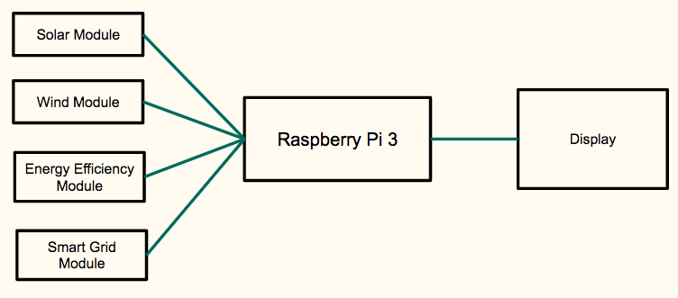

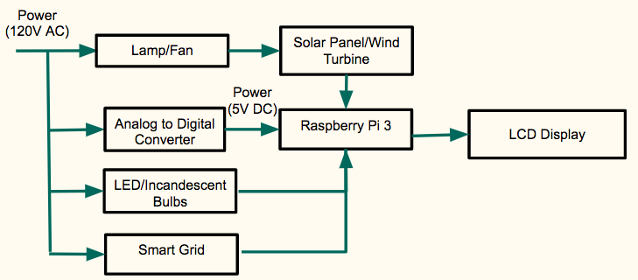

Figure 3. System Block Diagram

# First Semester Progress

* 1. **Circuit Design**

The solar module circuit design was completed to meet hardware and safety requirements. Using a 5 to 1 ratio voltage divider, the solar voltage input was stepped down to a usable voltage for data acquisition devices such as an MSP430 or Raspberry Pi 3. The visual LED load, along with a current limiting resistor, runs in parallel with the voltage divider. This allows the visual load to maintain the required voltage and brightness while also keeping current in the micro amp range. Similar circuit designs will be used for the wind and energy efficiency modules.

**4.2 Data Acquisition**

An MSP430 microprocessor was used as the solar module’s data acquisition device. Using an analog to digital converter, the stepped down voltage from the voltage divider was read. After acquiring this voltage, it was then stepped back up by a calculated factor. This value is then outputted and read similar values to a multimeter within 3% error. Future data acquisition will use a Raspberry Pi 3 instead of an MSP430. The Raspberry Pi has more GPIO pins to measure voltage and current from each module. Using the MSP430 provided the logic for the future data acquisition.

**4.3 User Interaction**

A main requirement for the project is user interaction. A National Grid customer can actively vary the solar panel’s power output using provided lighting films. The films will simulate different weather patterns or times of day. Mounting a color wheel over the light allows the user to switch through the films and watch the visual load change in brightness. The effects of films on voltage output and the LED load are shown in figure 4.

|  |  |  |  |  |  |  |  |
| --- | --- | --- | --- | --- | --- | --- | --- |
| Filter | Trial 1 (V) | Trial 2 (V) | Trial 3 (V) | Trial 4 (V) | Avg Voltage | LED On? | Rank |
| None | 9.03 | 9.00 | 8.99 | 9.00 | 9.005 | Yes | 1 |
| Yellow | 8.85 | 8.80 | 8.83 | 8.88 | 8.84 | Yes | 3 |
| Orange | 8.92 | 8.90 | 8.86 | 8.93 | 8.9025 | Yes | 2 |
| Pink | 8.76 | 8.71 | 8.72 | 8.70 | 8.7225 | Yes | 4 |
| Purple | 8.30 | 8.26 | 8.23 | 8.29 | 8.27 | Yes | 5 |
| Red | 8.28 | 8.23 | 8.23 | 8.29 | 8.2575 | Yes | 6 |
| Green | 8.18 | 8.14 | 8.15 | 8.18 | 8.1625 | Yes | 7 |
| Light Blue | 7.58 | 7.52 | 7.54 | 7.58 | 7.555 | Yes | 8 |
| Dark Blue | 6.70 | 6.45 | 6.61 | 6.70 | 6.615 | No | 9 |

Figure 4. Deliverable Test Results

**4.4 Significance**

Completion of the solar module accounts for one fourth of the project and provides proof of concept for the overall project. With the solar module having similar circuit designs and data acquisition as other modules, the conceptual design phases for these has begun. The data acquisition software will be translated from C to Python for use on a Raspberry Pi, but the logic will remain. With the solar module complete and progress in other modules, there is more time to focus on other aspects of the project.

# Technical Plan

Task 1. CAD Models

Models for the city of Boston will be designed in Solidworks, 3D printed, and painted in order to create the aesthetic of the project. Specific models that will be made are the National Grid LNG Tower, Fenway Park, skyscrapers, houses, and buildings in the city of Boston, and electric vehicle charging stations. These need to be lightweight and to scale of the project.

Lead: Jessica; Assisting: Makenna

Task 2. Data Acquisition Software

A Raspberry Pi 3 will be used to read voltage and current, then calculate the power generated/consumed in each module. The Raspberry Pi will be able to send that data to the LCD displays so the user can see how much power is generated or consumed. This data will be consistent throughout the different modules. The data should also be able to show how much each module affects the city as a whole.

Lead: Steven; Assisting: Jennifer

Task 3. LCD Displays

The LCD displays will present the data for each module. For the solar and wind modules, the display will show the power generated by the solar panels and wind turbines respectively. For the energy efficiency module, the LCD screen will display the power consumed by the LEDs/incandescent light bulbs. For the Smart Grid module, the display will consist of two screens. One screen showing the data for the Smart Grid; number of customers out, number of total customers, and duration of the power outage. The second screen will display how each module affects the city of Boston as a whole;the city’s “green percentage,”, Boston’s total need, and renewable contribution. These screens will be user friendly, professional and aesthetically pleasing.

Lead: Jennifer; Assisting: Steven

Task 4. PCB Design/Circuitry

Each module will have a safe and functional circuit design that limits voltage to less than 15V and current to less than 30 mA. The design should be neat and easily soldered. The design will be tested with a strip of LEDs rated to 12V.

Lead: Cameron

Task 5. Wind Module

Five wind turbines will be designed, fabricated, and tested. Each turbine will have interchangeable blades. This will show the user how the shape of turbine blades affect power generation. These wind turbines will be connected to a DC generator to drive a visual load (the Boston Citgo sign). An included LCD screen will display the power generated by the wind turbines. An additional wind turbine will be added so that the user can manually turn the blades, this turbine adds user interaction. This module should be clean, aesthetically pleasing, and work cohesively with the other three modules. Lead: Makenna; Assisting: Cameron

Task 6. Energy Efficiency Module

LEDs and incandescent light bulbs will be wired through a 3D printed model of Fenway Park. A switch will be added so that the user can toggle between the different light bulb types. Since both types are given the same amount of power, a potential design variation will use the excess power given to the LEDs to drive a separate load (the T). This module will also be clean, aesthetically pleasing, and work cohesively with the other three modules.

Lead: Cameron; Assisting: Makenna

Task 7. Smart Grid Module

This module showcases the National Grid Smart Grid pilot program. Skyscrapers, houses, and transmission lines will be made to demonstrate a standard Boston neighborhood. Inside each building, there will be an LED to show that particular building has power. When a transmission line is disconnected, the LEDs in the corresponding transmission line circuit will go out, simulating a large scale blackout. The power will then be rerouted. One module display will show the duration of blackout as well as the percentage of customers without power. After rerouting the power, only 20% of the customers will be out. The second display will show how each module affects the city as a whole, with statistics such as the city’s “green percentage,” Boston’s overall energy need, and the renewable contributions. This module will also be clean, aesthetically pleasing, and work cohesively with the other modules.

Lead: Jennifer; Assisting: Cameron, Jessica, Makenna, Steven

Task 8. Overall Cohesion of Project

After finishing all the modules and other tasks, we will work on making each module look like they could be a part of one city and making sure that it is visually pleasing. We will also be testing each module’s compatibility and making sure each module does exactly what it is supposed to do. Supplemental materials will then be made so that this project can be operated by someone who has no engineering background. Lead: Everyone

# Budget Estimate

|  |  |  |
| --- | --- | --- |
| **Item** | **Description** | **Cost** |
| 1 | Solar Panels | $10 |
| 2 | Lamp | $25 |
| 3 | Light Filters | $12 |
| 4 | Raspberry Pi 3 Model B | $37 |
| 5 | LED Adhesive Strip | $7 |
| 6 | DC Generator | $15 |
| 7 | Fan | $20 |
| 8 | Incandescent Bulbs | $5 |
| 9 | LED Bulbs | $5 |
| 10 | LCD Screens | $120 |
| 11 | Bamboo Base | $50 |
| 12 | National Instruments myRIO **Donated** | **$200** |
|  | Total | $256 |

The estimated budget for the overall project is significantly below our $1,000 limit. If there are any unexpected budget issues, National Grid has agreed to buy supplementing project materials. The LCD screens required in each module account for nearly half of the estimated budget. With a total of 5 screens in the project, a dominating cost is expected. Based on prices found online, a small moderately priced LCD screen will cost $20-$25.

A Raspberry Pi 3 was chosen as the main data acquisition device. Professor Pisano also donated a National Instruments myRIO. A myRIO costs $150 - $250. If the myRIO is chosen as the data acquisition device, this donation significantly helps the budget.

# Attachments

# Appendix 1 – Engineering Requirements

Team #20 Team Name: SWEET

Project Name: SWEET City

|  |  |
| --- | --- |
| **Constraint** | **Specification** |
| Modular Design | Four modules that work separately in 2 pieces as well as together |
| Solar Module | Display power generation |
| Wind Module | Display power generation |
| Energy Efficiency Module | Display power consumption |
| Smart Grid Module | Simulate blackout and display response |
| Safe | Voltage < 15V, Current < 30 mA, no loose wires |
| National Grid Branding | Display National Grid Logo and work into Smart City theme |
| Mobility | 1 sq. yard, no more than 30 lbs |
| Interactive | Usable for ages 8 and up |

|  |  |
| --- | --- |
| **Objective** | **Mean** |
| Solar Interaction | Cloud and night simulation |
| Wind Interaction | Interchangeable turbine blades |
| Energy Efficiency Interaction | LED to Incandescent bulb switching |
| Smart Grid Interaction | Activate blackout |
| Theme | Show utility’s role in a city landscape |

# Appendix 2 – Gantt Chart

